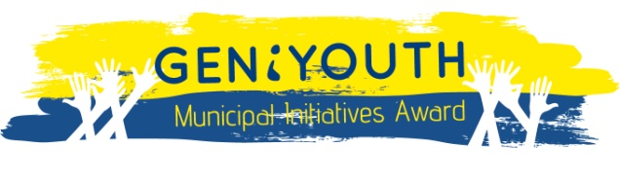

CALL FOR PROPOSALS GENiYOUTH Municipal Initiatives 2014:
APPLICANT DECLARATION
______________________________________________________________________________________________________________
V. DECLARATION

I, the undersigned, as legal representative of the institution/organization declare that the information provided in this Application Form are comprehensive and accurate. If the provided information do not comply with the reality, I do understand and accept the fact that the application will be immediately rejected.

Place and date

___________________________

Name and surname of the legal representative

____________________________

____________________________
(Signature of the legal representative and stamp of the organization)

